**Systems Programming**

Phase 2

Requirements and Design:-

The requirement was to build a two-pass assembler for the SIC-XE machine.

This is a SIC/XE Assembler with implementation of :

* Basic Assembler.
* Input format free.
* Error handling.
* Literals/org/equ support.

Input :

* Freely formatted SIC/XE assembly program.

Output:

* Object Code
* List File
* Symbol Table
* Addressing Mode (Flag bit)
  + Direct Addressing Mode
  + Indirect Addressing Mode
  + Simple Addressing Mode
  + Immediate Addressing Mode
  + Relative Addressing Mode
    - Program Counter (PC Register)

Functions used in Pass 2(prototypes):

def getObjectCode(format,i);

def getAddress(i);

def headerRecord();

def textRecord(startAddress , endAddress);

def endRecord();

def simpleExpressionEvaluation(i);

Sample Run:

* INPUT:

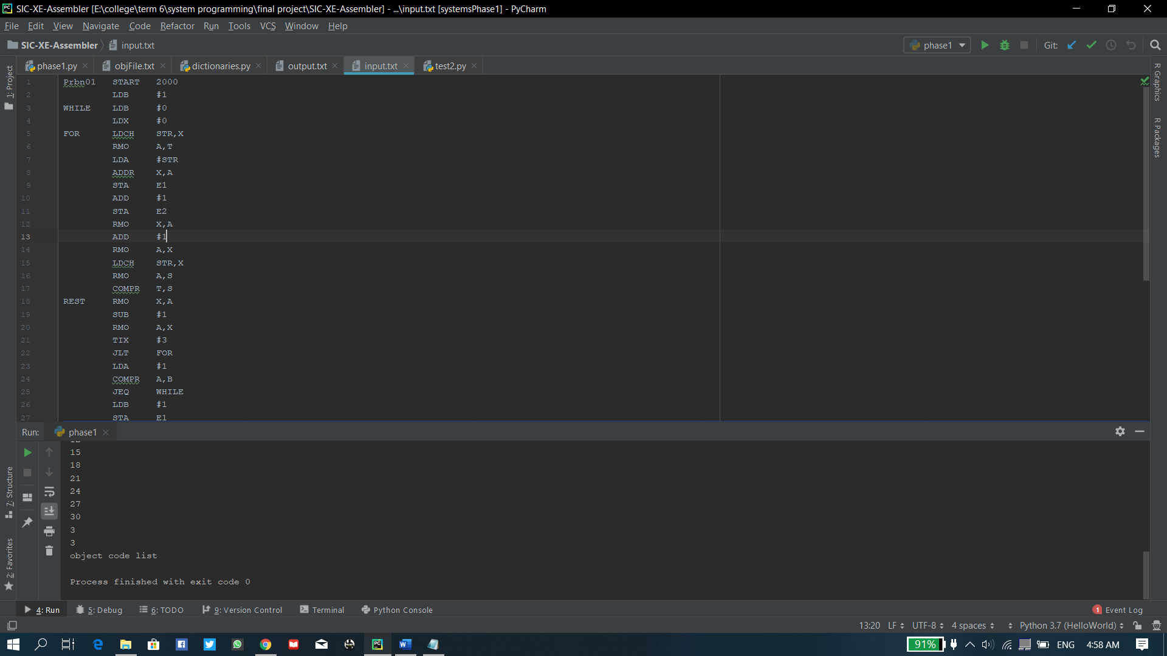

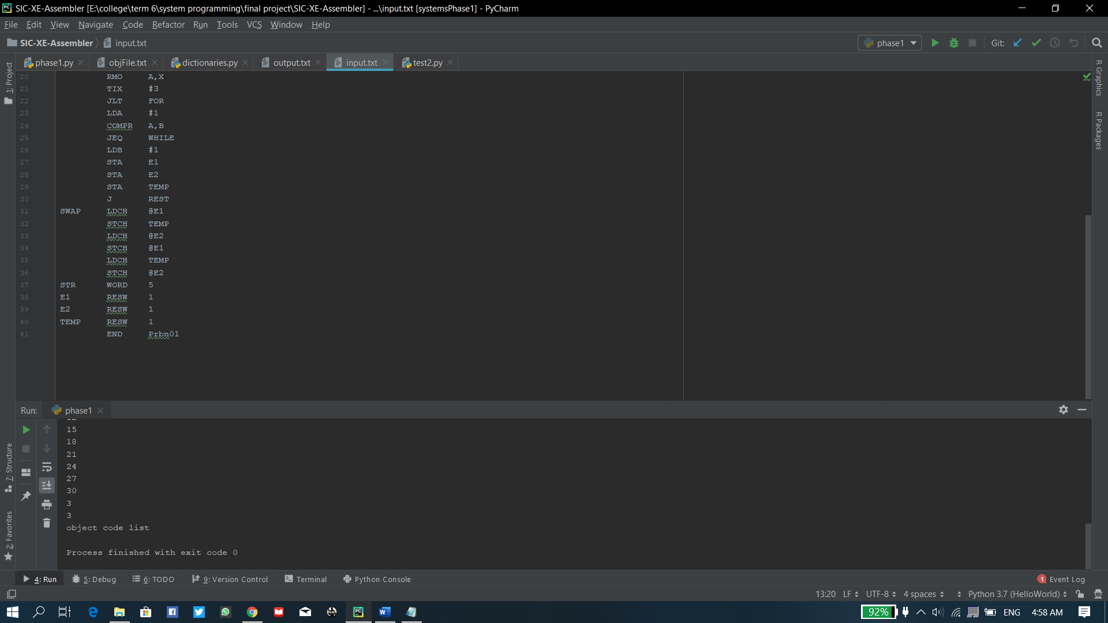

* OUTPUT:
* Symbol table:

Symbol table  
name address  
Prbn01 0X2000  
WHILE 0X2003  
FOR 0X2009  
REST 0X202A  
SWAP 0X204E  
STR 0X2060  
E1 0X2063  
E2 0X2066  
TEMP 0X2069

* List file:

Line no. Address Label Op-code Operands Comments   
1 0X2000 Prbn01 START 2000   
2 0X2000 LDB #1   
3 0X2003 WHILE LDB #0   
4 0X2006 LDX #0   
5 0X2009 FOR LDCH STR,X   
6 0X200C RMO A,T   
7 0X200E LDA #STR   
8 0X2011 ADDR X,A   
9 0X2013 STA E1   
10 0X2016 ADD #1   
11 0X2019 STA E2   
12 0X201C RMO X,A   
13 0X201E ADD #1   
14 0X2021 RMO A,X   
15 0X2023 LDCH STR,X   
16 0X2026 RMO A,S   
17 0X2028 COMPR T,S   
18 0X202A REST RMO X,A   
19 0X202C SUB #1   
20 0X202F RMO A,X   
21 0X2031 TIX #3   
22 0X2034 JLT FOR   
23 0X2037 LDA #1   
24 0X203A COMPR A,B   
25 0X203C JEQ WHILE   
26 0X203F LDB #1   
27 0X2042 STA E1   
28 0X2045 STA E2   
29 0X2048 STA TEMP   
30 0X204B J REST   
31 0X204E SWAP LDCH @E1   
32 0X2051 STCH TEMP   
33 0X2054 LDCH @E2   
34 0X2057 STCH @E1   
35 0X205A LDCH TEMP   
36 0X205D STCH @E2   
37 0X2060 STR WORD 5   
38 0X2063 E1 RESW 1   
39 0X2066 E2 RESW 1   
40 0X2069 TEMP RESW 1   
41 0X206C END Prbn01

* Object file:

H^Prbn01^2000^6c  
T^2000^690001^690000^050000^53A054^AC05^01204F^9010^0F204D^190001^0F204A^AC10  
T^201c^190001^AC01^53A03A^AC04^A054^AC10^1D0001^AC01^2D0003^3B2X2E^010001^A003  
T^203a^332X3C^690001^0F201E^0F201E^0F201E^3F2X24^522012^572015^52200F^562009  
T^2057^53200C^562006  
E^2000